Bio for VP Candidate Dr. Chuchu Wu

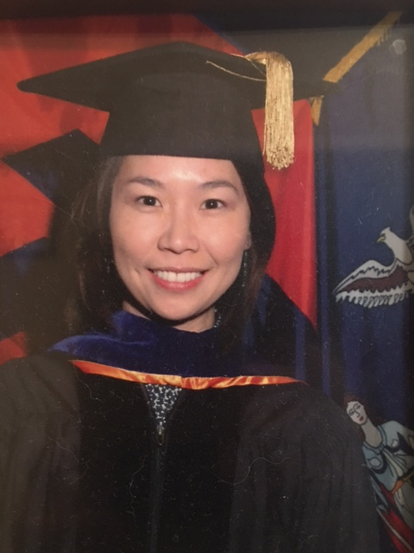

Dr. ChuChu Wu is currently teaching at Georgia Southwestern State University (GSW), Americus Georgia. She is an Associate Professor of P-5 Early Childhood Education in the School of Education at GSW. Dr. Wu is also the current GSW’s Institutional Review Board Chairperson for 2015-2016. She has been teaching at GSW for ten years. In addition to teaching undergraduate and graduate level courses, she serves as University Supervisor for Student Teachers and University Liaison for Professional Development Network Schools.

Dr. Wu received her Ph.D. degree in Child and Family Studies with a specialization in Early Childhood Education from Syracuse University in May 2007. She had the Master’s degree in Human Development and Family Studies from Iowa State University with specializations of Child Development and Early Childhood Education. She obtained her bachelor’s degree from the department of English Language and Literature at Fu-Jen Catholic University, Taipei Taiwan. Dr. Wu’s primary research interest lies in young children’s emergent literacy and numeracy development, parental involvement in early learning (e.g., parent-child story book reading interaction styles), parental beliefs about child rearing and literacy learning, and teachers’ beliefs about mathematics teaching and learning. Dr. Wu serves as journal and proposal reviewer as well as children book reviewer for National Association of Education for Young Children (NAEYC) and Southern Early Childhood Education Association (SECA).

Dr. Chuchu Wu has joined CAPASUS since 2006. She is a committed member and has been an active participant in several CAPASUS committees; for example, steering planning committee, activity planning committee, application review committee, Georgia state representative and social media and public relations committee.

